|  |  |
| --- | --- |
|  | **GST 113**  **NIGERIA PEOPLES & CULTURE** |
|  | Sarah AJIYA  Cordelia CLAYTON  Tobi JOHNSON  Dinatu B. TANKO  Felix ODOFIN  Cynthia M. SAIDU |

|  |
| --- |
| **[© 2019]** |
|  |



**INTRODUCTION**

**Section 1**

Lesson 1 Introduction to Nigeria and Citizenship

Lesson 2 People of Southern Nigeria I (Yoruba)

Lesson 3 People of Southern Nigeria II (Bini)

Lesson 4 People of Southern Nigeria III (IGBO)

Lesson 5 People of Southern Nigeria IV (Itsekiri, Urhobo, Ijaw)

**Section 2**

Lesson 6 People of Northern Nigeria I (Hausa/Fulani, Kanem-Bornu)

Lesson 7 People of Northern Nigeria II (Nupe, Jukun)

Lesson 8 People of Northern Nigeria III (Tiv, Igala)

Lesson 9 Dynamics of the Evolution of Nigeria Politically I (Pre-Independence)

Lesson 10 Dynamics of the Evolution of Nigeria Politically II (Post-Independence)

**Section 3**

Lesson 11 Cultural Area of the Niger-Delta Region of Nigeria

Lesson 12 Cultural Area of the Rain Forest Region of Nigeria

Lesson 13 Cultural Area of the Guinea Savanna Region of Nigeria

Lesson 14 Cultural Area of the Sudan Savanna Region of Nigeria

Lesson 15 Structure of Economic Activities in Nigeria

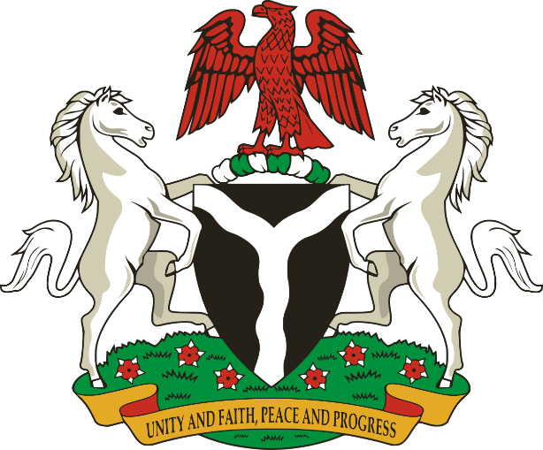

**INTRODUCTION OF THE ENTITY – NIGERIA**

Nigeria is a country situated in the Western region of Africa. It is bounded in the west by the Republic of Benin, on the North by the Republic of Niger, on the North-East, by Lake Chad, on the East by the Republic of Cameroun and in the south by the Atlantic Ocean. It has a total area of 923, 768 square kilometres - a total of 910, 768 landed mass and 13,000 square kilometres water ways. It is mostly located in the tropical region. Nigeria has an approximated population of about 200 million (National Population Commission August, 2019) people roughly equally divided between males and females and Christians and Muslims.

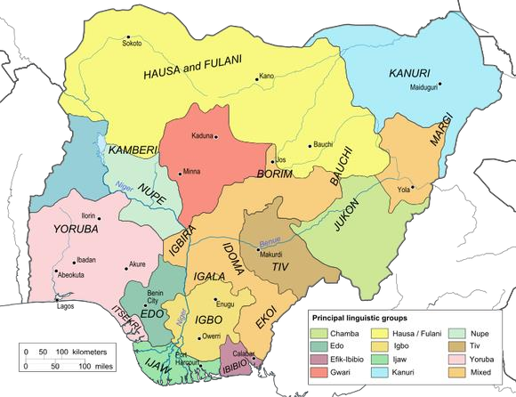As one moves from the south to the north, the vegetation progressively changes from tropical rain forest to savannah grassland. Typically, there are two main seasons: rainy season and dry season interspersed by the harmattan season. The rains are heaviest in the south and thinnest in the north. There are about 500 different ethnic groups within the boundaries of Nigeria. The major ethnic groups are Hausa, Igbo, Yoruba, Kanuri, Fulani, Bini, Tiv, Ijaw, and Nupe. There are some states that have more than ten different ethnic groups speaking different languages e.g Kogi and Adamawa. The ethnic, cultural and economic variations and long years of intermingling among the various groups have combined to produce very rich cultures and art forms which form the heritage of modern Nigeria

**LINGUISTIC CLASSIFICATIONS**

It is generally recognized that Nigeria is one of the principal linguistic crossroads of Africa. J.H. Greenberg in his classification of African languages distinguishes four major groups, called phyla. This in linguistics means a large division of possibly related languages, or a major language family which is not subordinate to another.

1. Afro-Asiatic

2. Khoisan

3. Niger-Congo

4. Nilo-Saharan.

In Nigeria, the majority of the languages belong to the Niger-Congo Phylum, though there are a substantial number of languages belonging to the Afro-Asiatic phylum especially the Chadic family (Hausa, Marghi, Pabir-Bura, Bole, Karekare, Tangale, etc.). The Nilo-Saharan has Kanuri, Dandi, Teda and Zanna. There are no languages from the Khoisan phylum in Nigeria.



Due to linguistic diversities, the Federal Government has encouraged the citizens to employ English Language as a lingual franca, language of administration, education, trade and commerce, while attempts is being made to evolve a national language through its National policy on Education. The National Policy on Education makes it mandatory that language of immediate environment or community should be the medium of communication in early childhood education. The Junior Secondary School students are to be taught and examined in any of the three major indigenous Nigerian languages – Hausa, Igbo and Yoruba. The Senior Secondary School students are to offer one other indigenous Nigerian language other than their mother tongue. Besides the issue of national language, different states in Nigeria have dominant languages which unite them.

